**Program using Selection statements: Set2**

Q1) Write a program that calculates the user’s body mass index (BMI) and categorizes it as underweight, normal, overweight, or obese, based on the following table from the United States Centers for Disease Control:

BMI Weight Status

Below 18.5 Underweight

18.5–24.9 Normal

25.0–29.9 Overweight

30.0 and above Obese

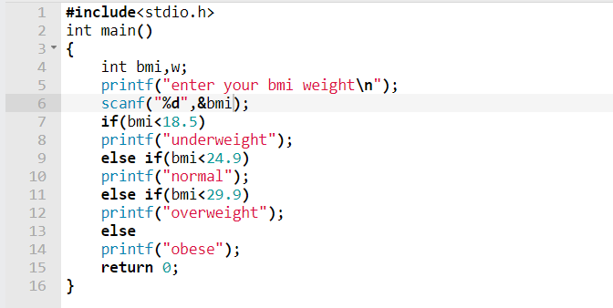

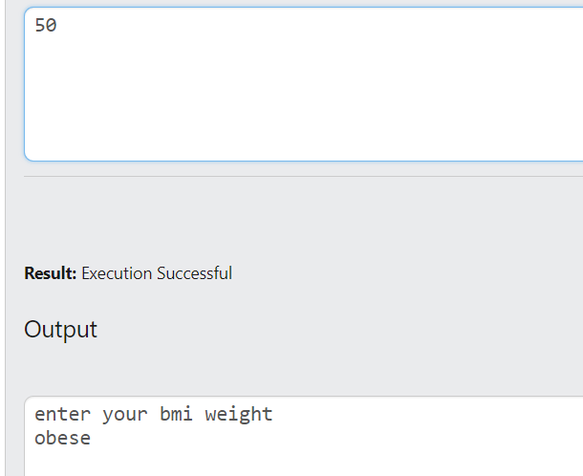

Q2) #include <stdio.h>

int main()

{

float n;

printf("\nEnter Richter Scale Number (n): ");

scanf("%f",&n);

if (n<5.0)

printf("\nLittle or no damage");

else if (n<5.5)

printf("\nSome damage");

else if (n<6.5)

printf("\nSerious damage; walls may crack or fall ");

else if (n<7.5)

printf("\nDisaster: houses and buildings may collapse ");

else

printf("\nCatastrophe: Most buildings destroyed ");

return 0;

}

Q3) simple

Q4) didn’t understand the question

**Programs using switch case:**

Q1) Write a menu-driven program using Switch case to calculate the following: 1. Area of circle 2. Area of square 3. Area of sphere

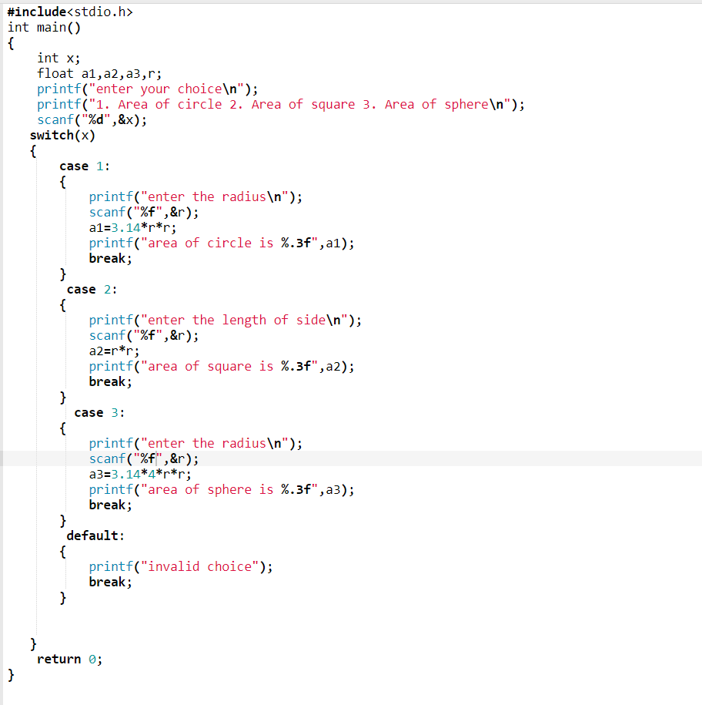

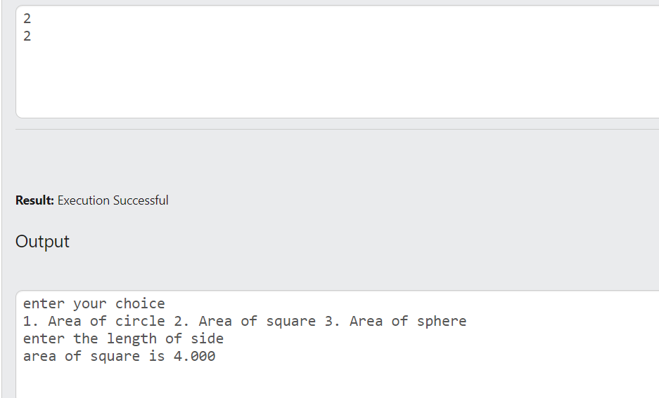

Q2) [Write a C program to check whether an alphabet is vowel or consonant using switch case.](https://codeforwin.org/2015/06/c-program-to-check-vowel-or-consonant-using-switch-case.html)

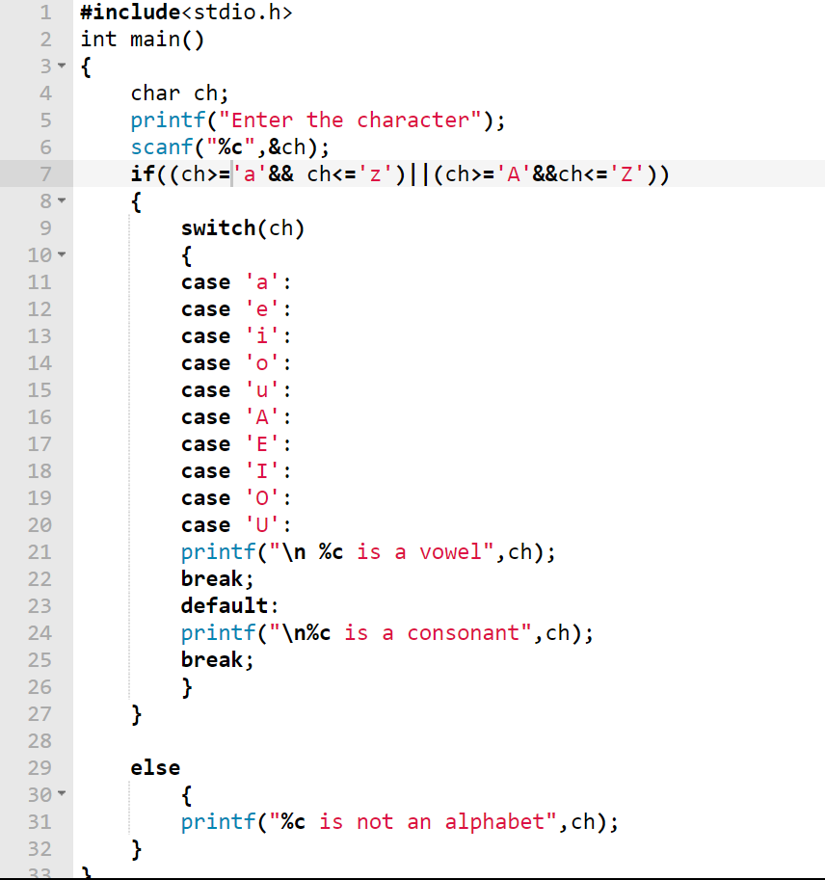

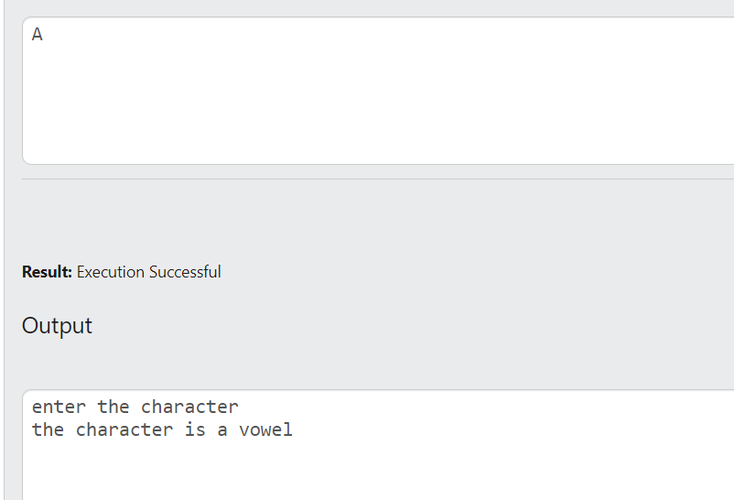

Q3) [Write a C program to find maximum between two numbers using switch case.](https://codeforwin.org/2015/06/c-program-to-find-maximum-using-switch-case.html)

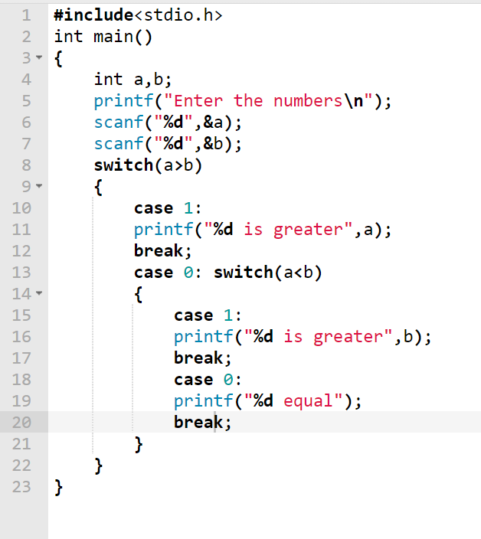

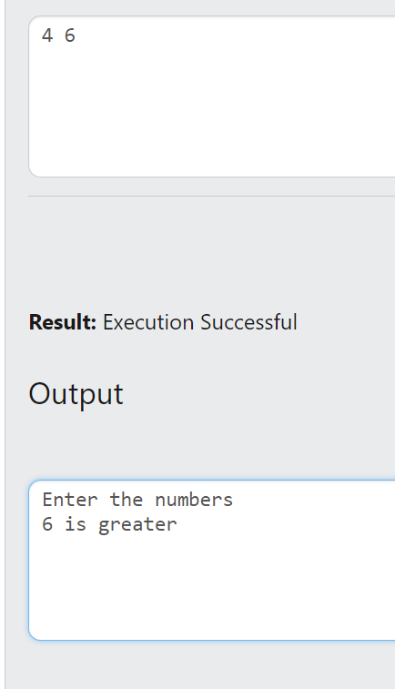

Q4) Write a C Program to check positive negative or zero using switch case

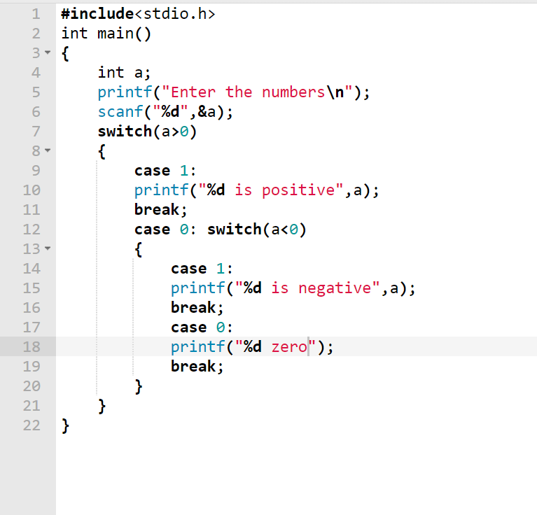

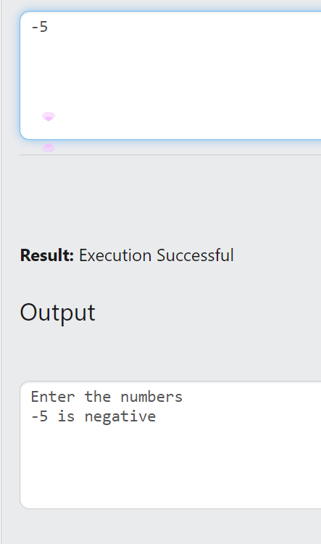

Q6) write a C program that displays the following menu for the food items available to take order from the customer:  
• B= Burger  
• F= French Fries  
• P= Pizza  
• S= Sandwiches  
The program inputs the type of food and quantity. It finally displays the total charges for the order according to following criteria:  
• Burger = Rs. 200  
• French Fries= Rs. 50  
• Pizza= Rs. 500  
• Sandwiches= Rs. 150

